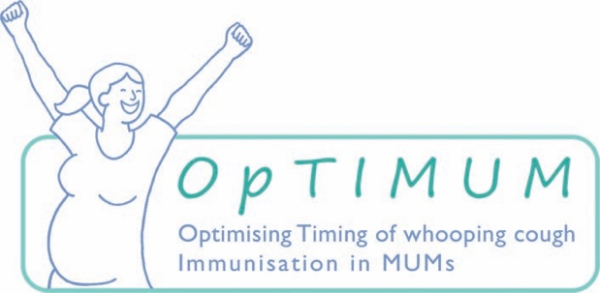
INFORMED CONSENT FORM

Participant number: __________________________
Participant name: ____________________________
Participant date of birth: ______________________
Study Title: | OpTIMUM
Protocol number | Version XX, XX-XX-XXXX
Study Sponsor: | St George’s, University of London
REC reference | 19/YH/0050
IRAS number | 249236

Please initial
I have read and considered the Participant Information Sheet (version XX, XX.XX.XX) about the OpTIMUM study. This leaflet provides enough information so that I understand what is involved and any questions I had about the study have been answered to my satisfaction.
I consent to my GP being informed about my participation in this study. I agree that if the study team is unable to contact me during this study they may ask my GP for my contact details and if I change my GP they may use my NHS number to find details of my new GP.
I understand that relevant sections of medical notes and data collected during the study may be looked at by the researchers, the Sponsor, my hospital and regulatory authorities.
I give permission for these individuals to have access to these notes where it is relevant to
my participation in this research.
I agree to the processing of my personal data as explained in the section on "How will my personal data be handled?" of the Participant Information Sheet (version XX XX.XX.XX) which I have read and understood.
I understand that I will be randomised (allocated by chance) to one of the three timing groups and I will receive my whooping cough vaccine according to this
I consent to being given the whooping cough vaccine by a member of the study team and having three blood samples taken
I consent to a cord blood sample being taken and I understand that if this is not obtained a member of the study team will ask for my permission to take an additional blood sample from my baby
I consent to my baby having a blood sample taken by a member of the study team after they have completed their first set of vaccinations
I understand that participation is voluntary and that I may withdraw from the study at any time without having to give a reason and that this will not affect my routine care
I understand that if I withdraw from the study any data or samples which have already been collected can continue to be used
I agree to take part in the study
OPTIONAL: If I decide to breastfeed I consent to providing a sample of colostrum and two samples of breastmilk as explained in the Participant Information Sheet
OPTIONAL: I agree that any remaining blood may be used for further ethically approved research to help improve the understanding of immunity in pregnancy & infancy
OPTIONAL: I agree that any remaining breast milk may be used for further ethically approved research to help improve the understanding of immunity in pregnancy & infancy

Signed:
Date:
Name (block capitals):

I have explained and discussed the study with the above participant. I have answered all her questions regarding the study and I am satisfied that the above signature denotes her informed consent to take part in the trial.

Signature of study staff: Date:
Name (block capitals):

